39.53: a) 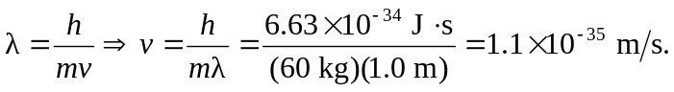
b) 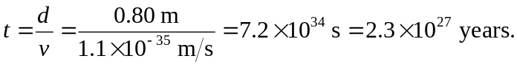
Therefore, we will not notice diffraction effects while passing through doorways.

